Aerosol optical properties and distribution during the extreme Arctic haze event in the spring 2006

Cathrine Lund Myhre¹, Carlos Toledano², Kerstin Stebel¹, Max Frioud³,
Karl Espen Yttri¹, and Mona Johnsrud¹

¹ Norwegian Institute for Air Research, Kjeller & Tromsø, Norway
² Grupo de Óptica Atmosférica (GOA-UVA), Universidad de Valladolid, Spain
³ ALOMAR, Andøya Rocket Range, Andenes, Norway

Keywords: optical properties, arctic haze, AOD

INTRODUCTION

In the Polar Regions the direct radiative effect of anthropogenic aerosols requires special attention due to the surface conditions in the region. Ice and snow have very high albedos, whereas water has a very low albedo. As a consequence, the importance of light-absorbing aerosols is even larger in the Arctic than elsewhere, as atmospheric absorption is enhanced by the high surface albedo of snow and ice. The radiative effect of anthropogenic aerosols in this region is largely uncertain.

During spring 2006 a special meteorological situation occurred in the European Arctic (sector) resulting in record level of pollution (Stohl et al., 2006). The temperatures were very high and the monthly mean temperatures for January, April and May were the highest ever recorded. The synoptic situation resulted in extensive transport of pollution into the region and record high air-pollution levels were measured at the Zeppelin observatory at Ny-Ålesund (78º 54'N, 11º 53'E) in the period from 25 April to 12 May. Stohl et al. (2006) reported a maximum value of aerosol optical depth at Ny-Ålesund of 0.62 at 500 nm. This is the highest value ever measured since the measurements started in 1991. For comparison, the mean arctic haze level during the period 1991-1999 is 0.133 (at 532 nm), whereas it is 0.071 for the spring background (Herber et al. 2002). According to Stohl et al. (2006), the origin of the pollution event was agricultural fires expanding to forest fires in Eastern Europe. These fires result in substantial amounts of aerosols and other pollutants, which were transported in to the European Arctic region. At the Zeppelin observatory concentrations of PM_{0.7} were estimated on the basis of DMPS measurements providing a maximum daily concentration of 29 μg m⁻³ on the 3rd of May. Other pollutants such as O₃ and CO reached concentrations of 83 ppb and in excess of 250 ppb, respectively. These are the highest levels ever recorded at this site (Stohl et al., 2006).

In the ongoing study we investigate the optical properties of the aerosols from this extreme haze event in the period from 25 April - 12 May 2006. We examine the aerosol optical properties from the source region and into the Arctic to explore the evolution of the plume and possible changes in optical properties. A number of sites in Eastern Europe, Northern Scandinavia and at Svalbard allow a regional characterization of the aerosol optical properties by means of remote sensing instruments. In addition we will use daily MODIS AOD products when available. The use of satellite data allows a more complete picture of the episode and its evolution in time and space.

Preliminary Results

We have analysed the AOD in the region based on MODIS data and ground based observations. The MODIS data coverage in the relevant region is not complete as satellite measurements of aerosol properties in the Polar Regions are difficult due to high surface albedo, large solar zenith angle, and long path through the atmosphere. Further the AOD retrievals are not performed in cloudy areas or in regions with high surface albedo such as snow and ice surfaces. To increase the data coverage, we have combined the MODIS data from Terra and Aqua in this study by adding Aqua data when there are no data from Terra available. In the period from 25 April - 12 May this increased the data coverage by 4.8%. The AOD at 550 nm retrieved from MODIS where in the range from 0.8 to well above 1 in the centre of the plume for the whole period.
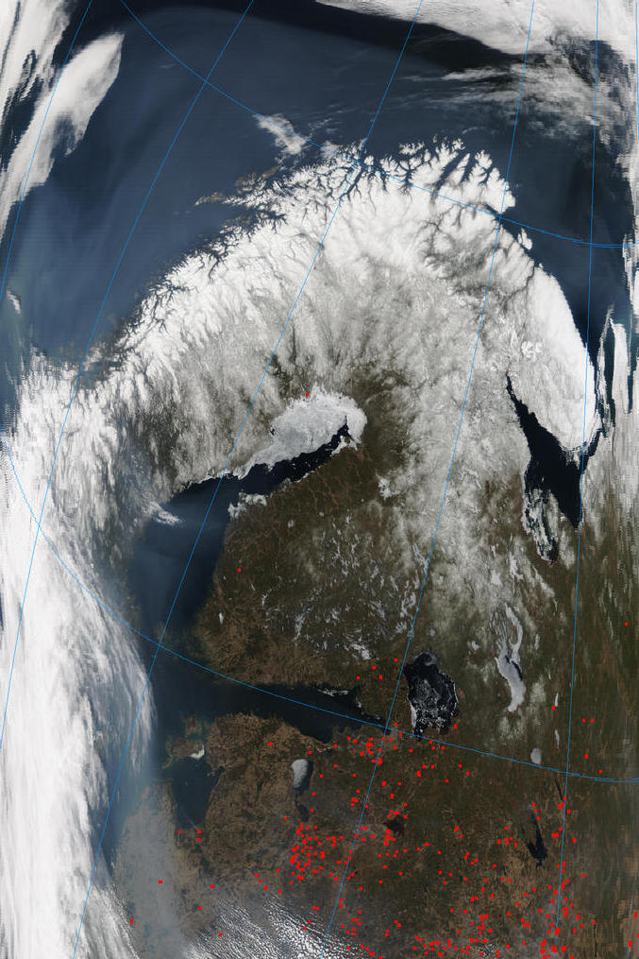
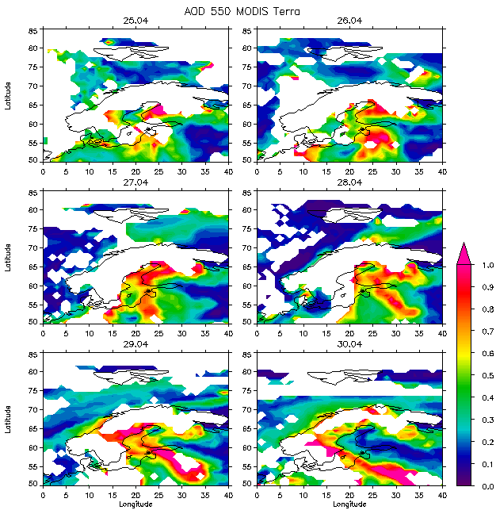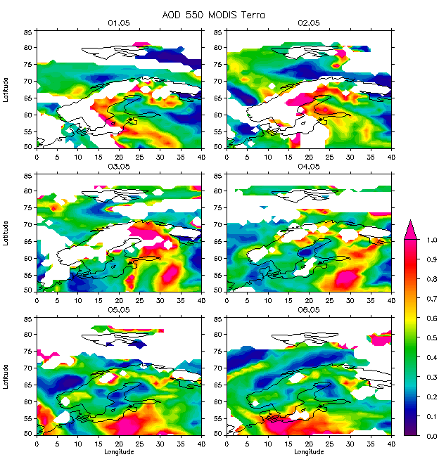
Figure 1: Upper panel: Picture taken by MODIS onbord Terra 30th April 2006. Lower panel: AOD retrieved from MODIS on Aqua and Terra presented for the same day.
⋅

The upper panel of Figure 1 shows a MODIS picture from the 30th April of the Baltic region, and Northern Scandinavia. Fires in Eastern Europe are indicated by red dots, and it is evident that the smoke is transported across Norway and Sweden and further along the Norwegian coast into the Arctic region. The red star indicates the ALOMAR observatory at the Northern coast of Norway. In the panel below are the daily level 3 AOD retrieved from MODIS presented for the same day. The MODIS AOD was very high, with maximum above 1.5 in the source region and values close to 0.5 around ALOMAR.

REFERENCES

Herber, A, Thomason, LW, Gernandt, H, et al., Continuous day and night aerosol optical depth observations in the Arctic between 1991 and 1999 (2002) J. of Geophys. Res. 107 (D10)

Stohl, A. Berg T., Burkhart J. F., Fjæraa A. M., Forster C., Herber A., Hov Ø., Lunder C., McMillan W. W., Oltmans S., Shiobara M., Simpson D., Solberg S., Stebel K., Ström J., Tørseth K., Treffeisen R., Virkkunen K., and Yttri K. E. (2006) Arctic smoke - record high air pollution levels in the European Arctic due to agricultural fires in Eastern Europe, submitted to Atmospheric Chemsitry and Physics, September 2006.

